IMPERIAL COLLEGE LONDON

BSc and MSci DEGREES – JANUARY 2014, for Internal Students of the Imperial College of Science, Technology and Medicine

This paper is also taken for the relevant examination for the Associateship

ADVANCED CHEMISTRY THEORY IIIA

Paper 2

Friday 17th January 2014, 14:00-17:00

PLEASE NOTE THAT IT IS DEPARTMENTAL POLICY THAT THESE EXAM QUESTIONS MAY REQUIRE UNDERSTANDING OF ANY PRIOR CORE COURSE.

USE A SEPARATE ANSWER BOOK FOR EACH QUESTION. WRITE YOUR CANDIDATE NUMBER ON EACH ANSWER BOOK.

Year 3/0114 Turn Over
3.I3 – Advanced Transition Metal Chemistry
Answer part a) AND part b) and EITHER part c) OR part d) of this question.

- Answer BOTH parts of this question.

- Draw structures for the organometallic compounds below and indicate the coordination mode of the organic ligand in each case. In the Zr complex, the C-C bond lengths in the butadiene ligand are found to be 1.45, 1.45 and 1.40 Å.

TiCp₄ WCp₂(CO)₂ ZrCp₂(C₄H₆)
(6 marks)

- A complex formulated as W(C₅H₅)₂ is found to display a resonance in the ¹H NMR spectrum at -3.45 ppm (amongst other resonances) and to obey the 18-electron rule as a bimetallic compound. Draw the structure.
(2 marks)

- Answer ALL parts of this question.

The iridium complex shown below is highly reactive and undergoes a C-H activation to form intermediate A and benzene. Compound A is also very reactive and readily decomposes into B or C.
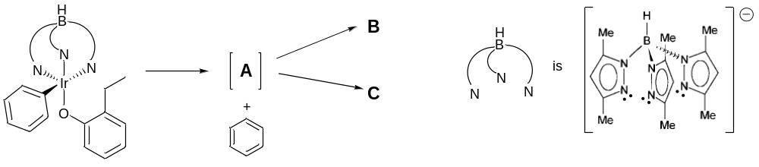

- Give the oxidation state and electron count for the original iridium complex.
(1 mark)
- Draw the structures of compound A.
(1 mark)

- All three compounds have the same empirical formula. Compounds B and C each display one signal between -17 and -21 ppm in their ¹H NMR spectra. Compound B exhibits a quaternary carbon resonance at 274 ppm in its ¹³C NMR spectrum. Compound C displays the signals representative of a monosubstituted alkene in its ¹H NMR spectrum. Draw the structures of B and C. Identify and describe the activation processes for the formation of B and C from A.
(5 marks)

QUESTION CONTINUED OVERLEAF
- Answer ALL parts of this question.
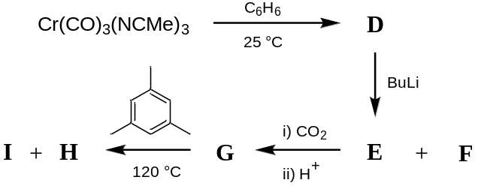

- Identify all compounds D to I and draw structures for the organometallic compounds. Compound D shows infrared absorptions in the range 1890-1970 cm⁻¹. One equivalent of gaseous hydrocarbon F is released on formation of E. Complex G shows a new absorption at 1682 cm⁻¹ in the infrared spectrum. Compound H displays two singlets in the ¹H NMR spectrum at 1.67 and 4.08 ppm in a 3:1 ratio. I is a colourless, crystalline organic compound with formula C₇H₆O₂. Not all by-products are shown in the scheme.

(8 marks)

- Comment on the relative pK_{a} values of G and I. Which compound will display the larger pK_{a} value and why?

(2 marks)

- Answer ALL parts of this question.

Tebbe’s complex is in equilibrium with a terminal methylene complex (alkylidene). This compound is a well known reagent for the olefination of carbonyl compounds.

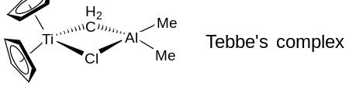

- Propose a preparation of Tebbe’s complex from [Cp₂TiCl₂].
(2 marks)

- Draw the equilibrium of Tebbe’s complex with a methylene complex. How could this equilibrium be displaced towards the methylene complex?
(2 marks)

- Propose a mechanism for the reaction of Tebbe’s complex with a ketone.
(4 marks)

- Similarly, Tebbe’s complex can react with acetonitrile (CH₃C≡N) to produce a new organometallic compound. Propose a mechanism for this transformation.
(2 marks)
3.O12 – An Introduction to Reaction Stereoelectronics
Answer parts a) AND b) and EITHER part c) OR part d) of this question.
- Answer BOTH parts of this question.
Consider the two diastereoisomeric decalin derivatives 1 and 2 shown below.
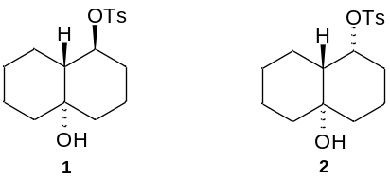
- Draw clear conformational diagrams of the two diastereoisomers.
(3 marks)
- On treatment with base, one of the diastereoisomers fragments to give a ring expanded product whereas the other does not react. Draw the ring expanded product with full stereochemistry and explain the contrasting behaviour of the two diastereoisomers.
(7 marks)
- Answer BOTH parts of this question.
Shown below is part of a synthesis of juvenile hormone as developed by scientists at Syntex.
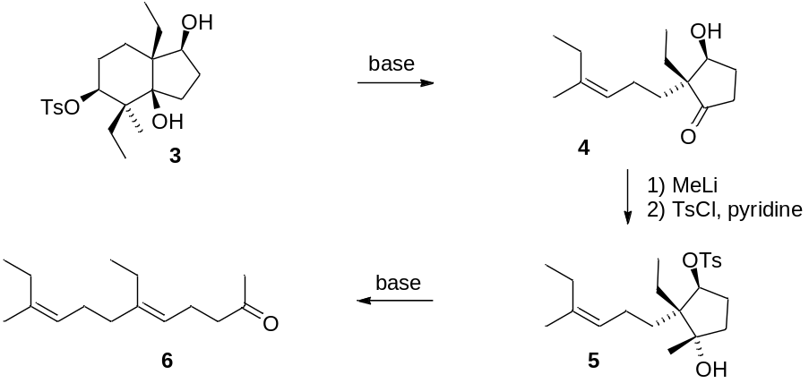
- Draw a mechanism for the rearrangement 3 → 4 including in your answer an explanation of the stereoselectivity of the transformation and diagrams of the key orbitals which are involved.
(5 marks)
QUESTION CONTINUED OVERLEAF

- Draw a mechanism for the rearrangement 5 → 6 including in your answer an explanation of the stereoselectivity of the transformation and diagrams of the key orbitals which are involved.
(5 marks)
- Answer BOTH parts of this question.
- Explain the geometrical requirements for deprotonation α to a carbonyl group by a base. Include in your answer an annotated diagram of the orbitals involved.
(2 marks)
- Predict the major product of the following reaction and explain your reasoning.
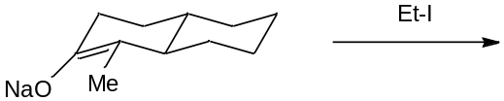
(3 marks)

- cis-Dihydroxylation of carbapenem 7 and then spontaneous elimination of phenyl sulfinic acid gives aldehyde 8, which upon heating rearranges to form carbacepham 9. Draw a mechanism for the rearrangement 8 → 9, including in your answer an explanation of the stereoselectivity of the transformation and diagrams of the key orbitals which are involved.
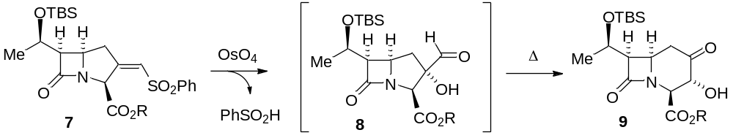
(5 marks)

3. O5 – Reactive Intermediates

Answer part a) OR part b) of this question.

- Answer BOTH parts of this question.

- Discuss the possible cyclisation modes of the 5-hexenyl radical and identify the preferred cyclisation mode.
(10 marks)

- Provide a detailed, annotated mechanism for the transformation shown below commenting on all aspects of selectivity.

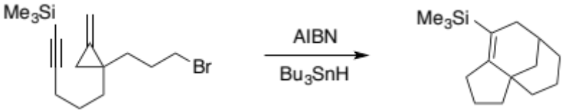

(15 marks)

- Answer BOTH parts of this question.

- Give the general structure of a singlet carbene showing the relevant orbitals and electron distribution, and show how such carbenes cyclopropanate cis-alkenes.
(10 marks)

- Provide a detailed, annotated mechanism for the transformation shown below commenting on all aspects of selectivity.
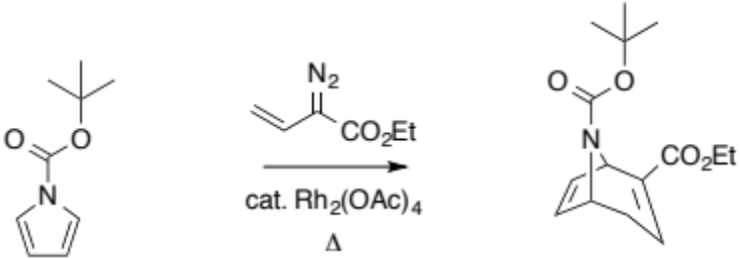
(15 marks)

3P11 – Statistical Thermodynamics

Answer part a) and EITHER part b) OR part c) of this question.

- Answer ALL parts of this question

- State the Boltzmann equation for entropy, defining all the terms in your equation. Show that the Boltzmann entropy is extensive upon increasing the number of particles in a system.
(2 marks)

- Consider a water molecule moving in a volume of 10³ nm³. Using the ideal gas approximation calculate the translational partition function of a water molecule at 300 K. What is the significance of the translational partition function?
(3 marks)

[Data: m_{water}=18 g/mol]

- Use the equipartition principle to estimate the heat capacity of water in the vapour phase at 400 K, and explain the difference between your result and the experimental heat capacity at this temperature, 26 J K⁻¹ mol⁻¹.

(Useful information: the vibrational temperatures for the water molecule are larger than 1000 K, and the rotational temperatures are lower than 50 K).
(5 marks)

- Consider the ionization process, Li → Li⁺ + e⁻ . What is the electronic partition function of the reactants and products in their ground states?

What would be the change in pressure in the system associated with the ionization process?
(3 marks)

- Write the statistical thermodynamic equation for the equilibrium constant of the chemical reaction: 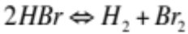. Explain all the terms in your equation and state what degrees of freedom need to be included to calculate the equilibrium constant.
(2 marks)

QUESTION CONTINUED OVERLEAF

- Answer ALL parts of this question

The partition function for one proton in a magnetic field can be represented as
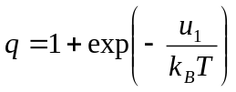

where the energy can adopt two values, 0 and u₁ depending on whether a magnetic field is applied or not.

- What is the total partition function for a system consisting of N distinguishable protons? What would be the partition function in the infinite temperature limit?
(3 marks)

- Derive an expression for the energy of the system described in i). Sketch the temperature dependence of the energy and show mathematically what is the limiting behaviour of the internal energy at T→0 and T→infinity.
(5 marks)

- The heat capacity of the proton system is expected to feature a maximum at low temperatures. Explain this observation.

(2 marks)

QUESTION CONTINUED OVERLEAF

- Answer BOTH parts of this question

- A CO molecule moves on a two-dimensional graphene surface of lateral length L. The translational energy of the molecule is given by:

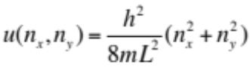

Show that the molecular partition function is given by: 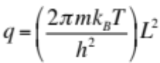

Hint: You may want to use the following integral in your derivation 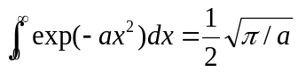
(6 marks)

- Assuming that the graphene lateral length is L=20 nm. Would the classical limit approximation be accurate to calculate the translational kinetic energy of the molecule at 20 K?

Rationalize your response considering two of these: number of accessible energy levels, energy separation between levels or the de Broglie wave length of CO.
[Data: M_{CO}=28 g/mol]

(4 marks)

